EXPERIMENT – 7

- How many students are registered for each course? Display the course description and the number of students registered in each course.
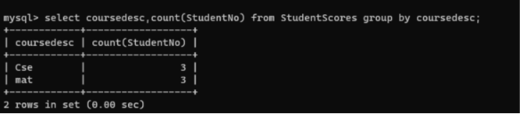

- How many courses did each student register for?
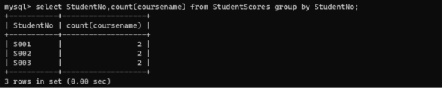
ORDER BY
- Retrieve Name, Gender, Mobile No of all the students in ascending order of Reg No.
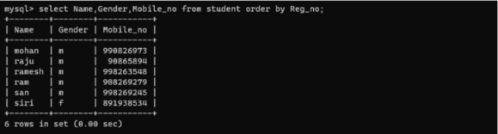
- List the faculty members in the order of older faculty first.
